The Holy Family School
4th primary
Unit.1
Page 9
- 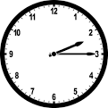 It is quarter past two

- 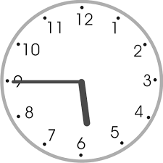 It is quarter to six

- 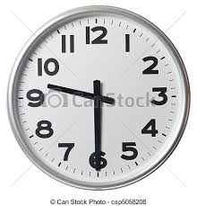 It is half past nine

Page 10
Complete the sentences with every day or at the moment:
- At the moment
- Every day
- At the moment
- At the moment
- Every day
- Every day
- Every day
- At the moment
- At the moment
- At the moment

Fill in am, is, are, do, and does:
- Are
- Does
- Are………..? No, I am not.
- Am
- Is ………? Mum is.
- Are
- Does……………….? Do.
- Does
- Is
- Does…………………..? No, I do it.

Page 11
A) Choose the correct verb form:
1- Mary usually goes to school by bus.
2- Listen! John is playing the violin.
I always do my homework after school.
They are watching television at the moment.
My sister is listening to music now.
We play football on Sundays.
Uncle Tom often drives his car.
Where is Mum?
She is cooking in the kitchen.
Emma sometimes helps her mum with the housework.
I am brushing my teeth now.
Does she visit her grandma every Saturday?
Are you playing computer games right now?
My brother doesn’t like geography.
We are not fighting at the moment.
Does your father work in a factory?
She isn’t learning English at the moment.
What time do they get up?
I don’t take the dog for a walk every day.
Where do they live? In a house or a flat?
Bill isn’t running now.

Page 12
- Observe the picture
- Answer the questions:
- Yes, it is.
- Yes, they are.
- No, he isn’t.
- Yes, they are.

B-What are they doing? Drag and drop the words in the correct place:
- The girls are riding their bikes.
- The boys are throwing a Frisbee.
- I am climbing a tree.
- John is hopping.
- Mary and Tom are running.
- Meg and Ryan are kicking a ball.

C-Observe the picture and write about what they usually do and what they are doing now:
- They usually skip the rope but today they are skating.
- They usually eat fish but today they are eating meat.
- They usually read but today they are listening to a text.

Page 13
- Is playing
- Do you go…………..?
- Are you shouting………….?
- Is falling
- Do you know…………………….?
- Do your parents drink…………………..?
- Are playing
- Are not looking
- Doesn’t eat
- Are you talking …………….?
- Is watching
- Do you live
- Does Sue like……………….?
- Are going
- Don’t ride
- Am not going
- Spend
- Aren’t listening
- Doesn’t read books. She prefers films.
- Is talking?

Page 15
Math: numbers 1+1=2
Science: Learn about plants
English: Read stories
Sport: Play basketball
Art: Paint and draw
Music: Learn piano

Yesterday I

Yesterday I ate noodles with a big plate of salad.
I played football with my friends.
The weather was sunny and hot.
I studied English and French.
I slept at nine o’ clock.

Page 16

I ate a cheese sandwich.
I played football with my friends.
I talked with my best friend.
I painted some pictures.
I watched my favourite show.
I visited my grandparents in the evening.
I went to the club.
I was very happy.

