Holiday fun!

Let’s start with something easy and fun!
Do you remember how to tell time? Show me 😊 remember there are also quarters.
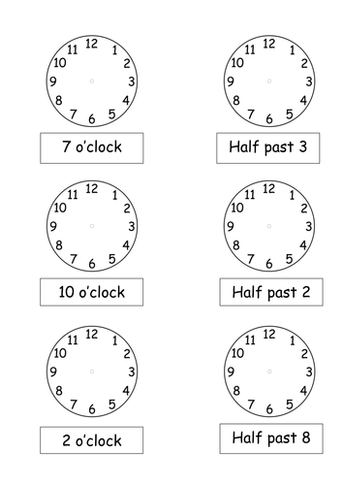

Now for even more fun, have a look at this short video.
https://www.youtube.com/watch?v=qD1pnquN_DM
There are 15 activities in this video did you catch them all??? 😊
Watch the video again and list all 15 activities. Have fun

1) | 6) | 11)
2) | 7) | 12)
3) | 8) | 13)
4) | 9) | 14)
5) | 10) | 15)

Great job !!!!

Since you are so good at this and now you know how to tell time and talk about activities try this exercise.
Using what you know pick 10 activities and use them to talk about your routine. Make sure to keep it interesting and to tell the time when you can.

________________________________________________________________________________________________________________________________________________________________________________________________________________________________________________________________________________________________________________________________________________________________________________________________________________________________________________________________________________________________________________________________________________________________________________________________________________________________________________________________________________________________________
You are a champion writer!
😊

Now for some easy peasy activities that you will enjoy. Colour and label 😊
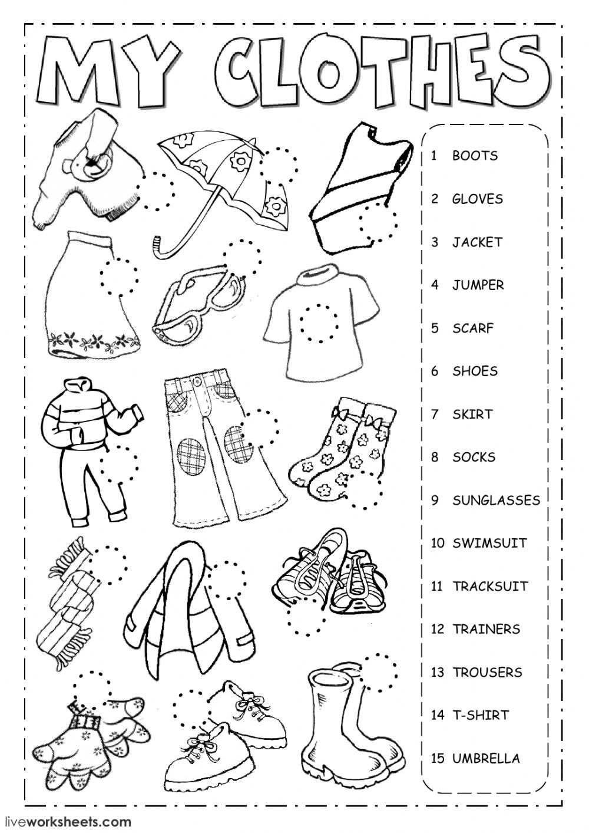
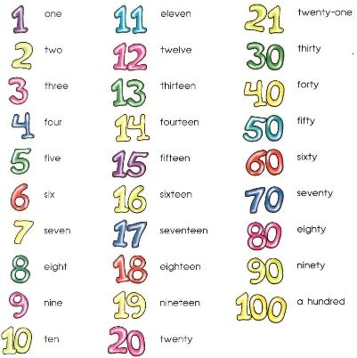
Now cover the sheet and try writing all the numbers again from your memory. If you get stuck ask your parents for help.

____________________ ____________________ ____________________
____________________ ____________________ ____________________
____________________ ____________________ ____________________
____________________ ____________________ ____________________
____________________ ____________________ ____________________
____________________ ____________________ ____________________
____________________ ____________________ ____________________
____________________ ____________________ ____________________
____________________ ____________________ ____________________
____________________ ____________________ ____________________
Now try and learn some new hobbies. Hobbies are things we enjoy doing in our spare time.
Now try writing about some hobbies that you like they don’t have to be in the sheet. Talk about why you like them? When do you do them? Did you do them during this holiday?
________________________________________________________________________________________________________________________________________________________________________________________________________________________________________________________________________________________________________________________________________________________________________________________________________________________________________________________________________________________________________________________________________________________________________________________________________________________________________________________________________________________________________

