Holiday fun!

Have a look at the following link
http://www.kizclub.com/storytime/Ican/Ican2.html
Now write 5 things that you can do 😊
- _____________________________________________________________________
- _____________________________________________________________________
- _____________________________________________________________________
- _____________________________________________________________________
- _____________________________________________________________________
Now write 2 things you cannot do ☹
- ___________________________________________________________________________________
- ___________________________________________________________________________________
Finally, write 3 things that you want to do next year.
- _____________________________________________________________________
- _____________________________________________________________________
- _____________________________________________________________________

Ready for some fun? Have a look at the pictures, see how many you can remember.
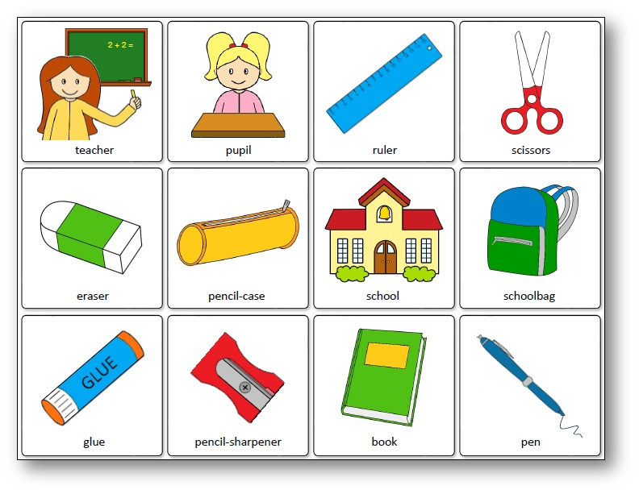

Now, are you ready to see how many you remember and learn a few new words?

Now see how many objects you can remember. Write the names of the objects that you know next to the object. If there are some you don’t know, ask your parents for some help 😊

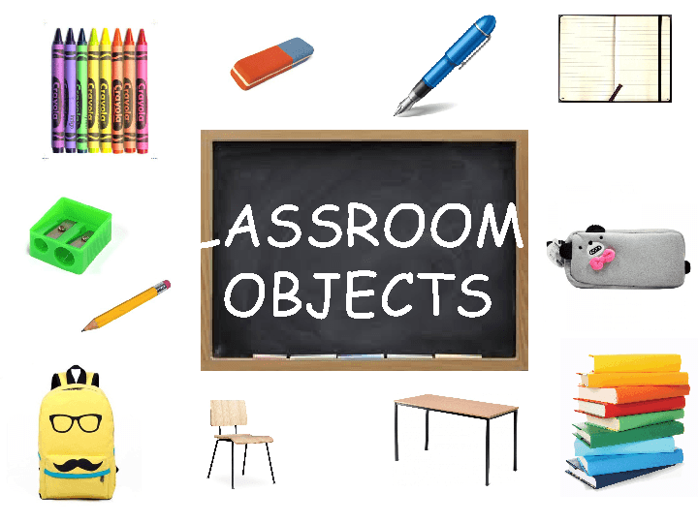

Now try answering this sheet on your own 😊

