Task 1: Read the story then answer 5th primary
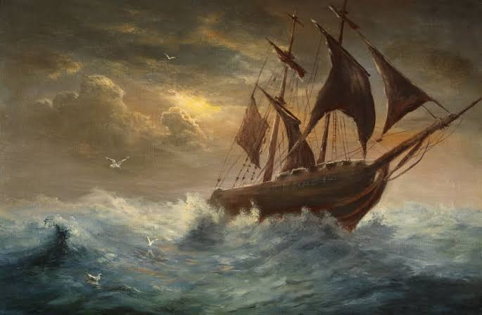
A SHIP IN A STORM
Did you ever go far out into the great ocean? How beautiful it is to be out at sea when the sea is smooth and still!
Let a storm approach, and the scene is changed. The heavy, black clouds appear in the distance and throw a deep, deathlike shade over the world of waters. The captain and sailors soon see in the clouds the signs of evil. All hands are then set to work to take in sail.
The hoarse notes of the captain, speaking through his trumpet, are echoed from lip to lip among the rigging. Happy will it be, if all is made snug before the gale strikes the vessel.
At last, the gale comes like a vast moving mountain of air. It strikes the ship. The vessel heaves and groans under the dreadful weight and struggles to escape through the foaming waters. If she is far out at sea, she will be likely to ride out the storm in safety. But if the wind is driving her upon the shore, the poor sailors will hardly escape being dashed upon the rocks and drowned.
Once there was a ship in a storm. Some of her masts were already broken, and her sails lost. While the wind was raging, and the billows were dashing against her, the cry was heard, "A man has fallen overboard!"
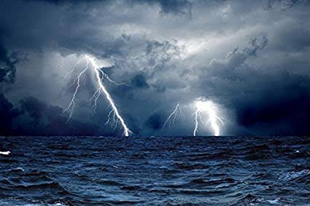
The boat was lowered quickly, and she was soon seen bounding on her way over the mountain waves. At one moment, the boat seemed lifted to the skies, and the next, it sank down and appeared to be lost beneath the waves!
Finally, the man was found. He had almost drowned; but he was taken on board, and now they made for the ship. But the ship rolled so dreadfully that it seemed certain the boat wouldn’t make it to her. And now, what should they do?
The captain told one of the men to go aloft and throw down a rope. This was tied fast to the boat, and when the sea was somewhat calm, the boat was hoisted and landed on the ship with a dreadful crash. It was a desperate way of getting on board, but fortunately no lives were lost. On the dangerous points along our seacoast are lighthouses which can be seen far out at sea and serve as guides to ships. Sometimes the fog is so dense that these lights cannot be seen, but most lighthouses have great fog bells or fog horns; some of the latter are made to sound by steam and can be heard for a long distance. These bells and horns are kept sounding as long as the fog lasts. There are also many life-saving stations along the coast where trained men are ready with lifeboats. "When a ship is driven ashore they at once go to the rescue of those on board, and thus many valuable lives are saved. Take it all in all; a sailor's life is a very hard one. Our young friends owe a debt of gratitude to those whose home is upon the great waters, and who bring them the luxuries of other countries.
After reading the previous text , think about this adventure and imagine you had your own one . Storm at Sea

Your best friend’s family invites you to join them on a deep-sea fishing expedition. When an unexpected storm sweeps your small boat farther out to sea, you find yourselves lost.
Write a story telling about what happens next. What vehicle, tool, and animal help you find your way back to dry land?

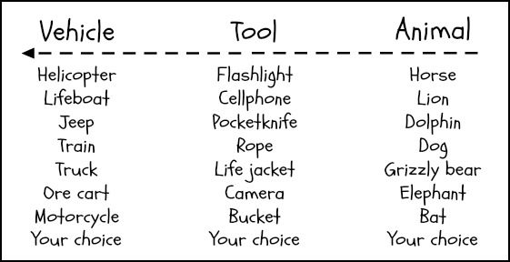
………………………………………………………….………………………….………………………….…………………………………………………….
………………………………………………………….………………………….………………………….…………………………………………………….
………………………………………………………….………………………….………………………….…………………………………………………….
………………………………………………………….………………………….………………………….…………………………………………………….
………………………………………………………….………………………….………………………….…………………………………………………….
………………………………………………………….………………………….………………………….…………………………………………………….
………………………………………………………….………………………….………………………….…………………………………………………….
………………………………………………………….………………………….………………………….…………………………………………………….
………………………………………………………….………………………….………………………….…………………………………………………….
………………………………………………………….………………………….………………………….…………………………………………………….
………………………………………………………….………………………….………………………….…………………………………………………….
………………………………………………………….………………………….………………………….…………………………………………………….
………………………………………………………….………………………….………………………….…………………………………………………….
………………………………………………………….………………………….………………………….…………………………………………………….
………………………………………………………….………………………….………………………….…………………………………………………….
………………………………………………………….………………………….………………………….…………………………………………………….
………………………………………………………….………………………….………………………….…………………………………………………….
………………………………………………………….………………………….………………………….…………………………………………………….
………………………………………………………….………………………….………………………….…………………………………………………….
………………………………………………………….………………………….………………………….…………………………………………………….

Word bank :

Let's play :
Past simple Crossword
1
2
3
4
5
6

7
8
9
10
11

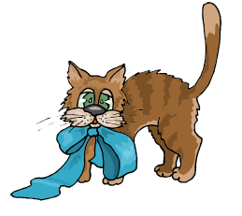
- First I .......... my homework then I went out to play.
- Yesterday I ............... to music.
- I .............. home today, I didn’t go out.
- We ................in Paris 3 years ago.
- Sam ............. down and broke his foot.
- Last week I ............ a letter to my friend.
- Suddenly he ............ a loud noise.
- Yesterday I ............. my jacket in school.
- I ............ my teacher in the park but I didn’t say hello.
- I ............... a lot of money on the street.
- I ............. very angry so I shouted at my friend but I was wrong.

Task 2:
Read the following text and then answer the questions:
The Mysterious Cupboard
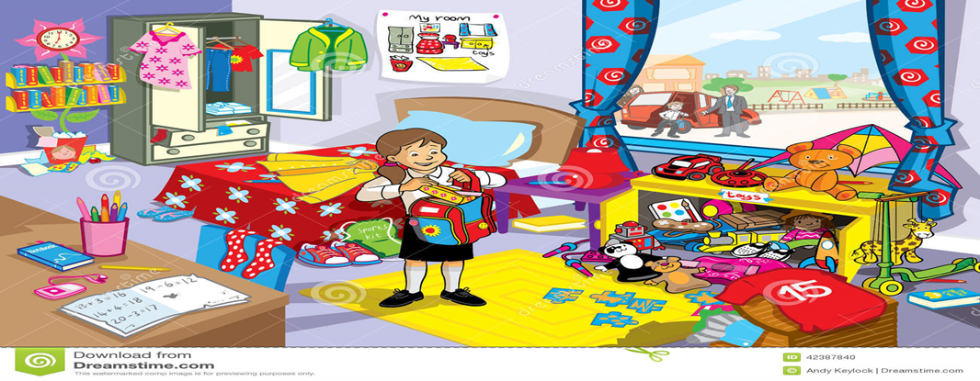
Tina and her family moved into a house in the country. It was large, old house. Tina’s bedroom was on the roof. When Tina looked around, the bedroom was a cheerful yellow colour. Some of her furniture was in the room. Her bed was under the window and her bookshelf was behind the door. In the middle of the floor there was a large pile of boxes. Each box had a big label on it: ‘TINA’S THINGS’.
Tina knelt down and opened the first box. It was full of books so they all go on the bookshelf and then they put the box outside to make more room.
Tina began to put the books on the bookshelf while mum was opening another box. When Tina finished putting the books, she began to pull things out of the box her mother had opened. There were old teddy bears, jigsaws, games and a bucket and spade.
Tina returned all the things in the box and mum opened the door of the large cupboard. She crawled in. It was dark inside. Tina wanted to see what it was like in the cupboard. She crawled in while mum was pushing the box. She pushed and pushed but it didn’t reach the back of the cupboard. This cupboard must be enormous. Tina crawled further in .She helped her mum push the box. When they crawled further into the cupboard, there was sand under their hands and feet and they can see sunlight. When they crawled towards the light, they soon found that they were on a beach. There was the sea. It was so blue. Mum followed Tina into the sunlight. They soon were standing on a beautiful beach with golden sand and palm trees.
‘ How did we get here ?’ asked Tina softly.
‘ A more important question is - can we get back again ? ’
A- Answer the following questions from the text
- What did Tina’s room look like ?
……………………………………………………………………………………………………………………………………………………………………………………………………………………………………………………………………………………………………………………………………………………………………………………………………………………………………………
2- What happened when Tina and her mum entered the cupboard?
………………………………………………………………………………………………………………………………………………………………………………………………………………………………………………………………………………………………………………………………………………………………………………………………………………………………………………………
3- In your opinion, how can they get back again?
…………………………………………………………………………………………………………………………………………………………………………………………………………………………………………………………………………………………………………………………………………………………………………………………………………
B- According to the previous text, write a story about a mysterious thing that happened to you
……………………………………………………………………………………………………………………………………………………………………………………………………………………………………………………………………………………………………………………………………………………………………………………………………………………………………………………………………………………………………………………………………………………………………………………………………………………………………………………………………………………………………………………………………………………………………………………………………………………………………………………………………………………………………………………………………………………………………………………………………………………………………………………………………………………………………………………………………………………………………………………………………………………………………………………………………………………………………………………………………………………………………………………………………………………………………………………………………………………………………………………………………………………………………………………………………………………………………………………………………………………………………………………………………………………………………………………………………………………………………………………………………………………………………………………………………………………………………………………………………………………………………………………………………………………………………………………………………………………………………………………………………………………………………………………………………………………………………………………………………………………………………………………………………………………………………………………………………………………………………………………………………………………………………………………………

